Framing.

1. Purpose of Framing
The data link layer provides services to the network layer using the physical layer's raw bit stream. The physical layer may reduce bit errors using redundancy, but cannot guarantee error-free delivery. Framing is the process of breaking the bit stream into discrete frames with checksums for error detection.
At the receiver side, the checksum is recalculated. If it differs from the received one, the frame is considered erroneous and may be discarded or retransmitted.
The main challenge is efficiently detecting frame boundaries while using minimal bandwidth.

2. Framing Methods

2.1 Byte Count
A field in the frame header specifies the total number of bytes in the frame. The receiver reads exactly that many bytes to identify the frame boundary.
Problem: If the byte count is corrupted, synchronization is lost and recovery is difficult.
Usage: Rarely used alone due to vulnerability to errors.
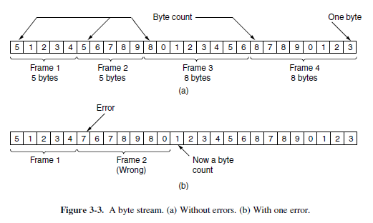

2.2 Flag Bytes with Byte Stuffing
Frames start and end with a special flag byte (e.g., FLAG). Two consecutive flags indicate the end of one frame and the start of the next.
If the flag byte appears in the data, an escape byte (ESC) is inserted before it. The ESC byte itself is also escaped if it appears.
At the receiver, escape bytes are removed before data is passed to the network layer.
Example: Point-to-Point Protocol (PPP).
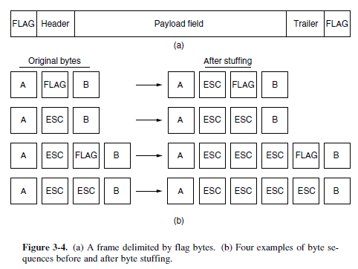
Flag bytes with byte stuffing is a framing technique used in data link layer protocols to delineate frames of data. It involves using a specific byte sequence (the flag byte) as a delimiter to mark the beginning and end of a frame. To handle cases where the flag byte sequence might appear within the actual data, a technique called byte stuffing (or character stuffing) is employed. This involves inserting an escape byte (often ESC) before any occurrence of the flag byte or escape byte within the data.
Here's a more detailed explanation:
1. Flag Bytes:
- A flag byte is a special byte sequence (e.g., 01111110 in many protocols) that serves as a delimiter to mark the start and end of a frame.
- The receiver uses this flag byte to identify the boundaries of each frame.
2. Byte Stuffing:
- The Problem:
When the actual data being transmitted contains the same byte sequence as the flag byte, it can be misinterpreted by the receiver as the end of the frame.
- The Solution:
Byte stuffing adds an escape byte (e.g., 01111101) before every flag byte within the data.
- The Process:
  - Sender: The sender inserts an escape byte before any flag byte or escape byte found in the data to be transmitted.
  - Receiver: The receiver removes any escape byte before a flag byte or another escape byte to reconstruct the original data.
- Example:
If the flag byte is 01111110 and the escape byte is 01111101, and the data is 01111110 10101010 01111101 01111110, it would be stuffed as 01111101 01111110 10101010 01111101 01111101 01111110.
3. Purpose:
- Framing:
Allows the receiver to correctly identify the beginning and end of each frame.
- Transparency:
Makes the data link layer transparent to the data being transmitted, meaning the data can contain any byte sequence without causing framing errors.
- Error Detection:
Helps in detecting errors, as corrupted frames can be identified by checksums or other mechanisms.
4. Key Terms:
- Flag Byte: A special byte sequence used as a frame delimiter.
- Escape Byte: A special byte sequence used to escape flag bytes within the data.
- Byte Stuffing: The process of adding escape bytes to handle flag byte occurrences within the data.
- Character Stuffing: Another term for byte stuffing.
- Framing: The process of encapsulating data into frames for transmission.

2.3 Flag Bits with Bit Stuffing
Bit-level framing allows frames of arbitrary size. Frames start and end with the bit pattern 01111110 (0x7E).
Whenever five consecutive 1s appear in the data, the sender inserts a 0 bit. The receiver removes this extra 0 bit.
Ensures that the flag pattern never appears within the data and aids clock synchronization.
Example: HDLC, USB.
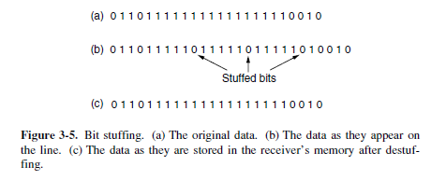
Flag bits with bit stuffing is a framing method used in the data link layer of computer networks to define the start and end of a data frame and prevent the flag sequence from appearing within the data itself.
Method Description:
Flag Pattern:
A specific bit pattern, typically 01111110, is designated as the flag. This pattern marks the beginning and end of each frame.
Bit Stuffing at Sender:
When the data link layer at the sender side prepares a frame for transmission:
It adds the flag pattern 01111110 at the beginning and end of the data payload.
To prevent the flag pattern from accidentally appearing within the actual data, a technique called "bit stuffing" is employed. If five consecutive '1' bits appear in the data stream, a '0' bit is automatically inserted (stuffed) after the fifth '1'. This ensures that the sequence 01111110 only occurs as a frame delimiter and not as part of the data.
Bit Destuffing at Receiver:
When the frame arrives at the receiver's data link layer:
The receiver scans the incoming bit stream for the flag pattern 01111110 to identify frame boundaries.
During the data portion of the frame, if the receiver encounters five consecutive '1' bits followed by a '0' bit, it automatically removes (destuffs) that '0' bit, restoring the original data stream.
Purpose and Advantages:
Clear Frame Demarcation:
The flag bits provide a clear and unambiguous way for the receiver to identify the start and end of each data frame, even in the presence of errors or lost synchronization.
Data Transparency:
Bit stuffing ensures that any arbitrary bit pattern can be transmitted as data without being misinterpreted as a control signal (like the flag).
Synchronization:
The consistent pattern of '1's and '0's in the flag and the stuffing mechanism can aid in maintaining bit-level synchronization between sender and receiver.

2.4 Physical Layer Coding Violations
Some physical layer encoding schemes leave certain signal patterns unused. These can be reserved to indicate the start and end of frames.
Example: In 4B/5B coding, 16 out of 32 codes are unused and can be used as delimiters.
Advantage: No need for stuffing, easy detection.

3. Common Practices
Many protocols combine multiple framing methods for robustness. For example, Ethernet and IEEE 802.11 use a preamble for synchronization followed by a length field in the header to indicate frame size.

4. Key Takeaways
- Framing is essential for identifying boundaries in the bit stream and enabling error detection.
- Choice of framing method depends on channel reliability, efficiency needs, and hardware constraints.
- Stuffing methods (byte or bit) ensure special patterns remain unique in the data.

